
Review Article OR Research Article |  | ISSN 2658-5553
Received: January 19, 2026 | Accepted: January 19, 2026 |  | Published: January 28, 2026

Bean pod epicarp ash concrete
Sezairov, Amirkhan Bahsat¹ 
Akbarli, Reyhan Sayyad^{1*}
Serdjuks, Dmitrijs²
Roset Calzada, Jaume³
Suwaed, Ahmed Shakir Hasan⁴
1 Azerbaijan University of Architecture and Construction, Baku, Azerbaijan Republic; sazairov_emirxan@mail.ru (S); somebody2@mail.ru (V.I.I.)
2 Riga Technical University, Riga, Latvia; somebody3@something.edu
3 Polytechnic University of Catalonia, Barcelona, Spain; somebody4@something.edu
4 University of Baghdad, Baghdad, Iraq; somebody5@something.edu
Correspondence:* email somebody2@mail.ru; contact phone +79214567889

Keywords:
Concretes; Calibration; Computer simulation; Constitutive models; Strength; Stress-strain curves; Static loads; Finite element method; Plasticity

Abstract:
The object of research is a flat statically determinate trapezoidal truss with a rectilinear lower chord and four supports, one of which is a pinned, and three are roller. This work aims to analyze the dependence of the deflection of the truss and the shift of the movable support on the size, load, and number of panels. The load concentrated in the middle of the span, the load uniformly distributed over the nodes of the upper or lower belt are considered. Method. The initial forces in the elements are determined in analytical form by method of joints in the Maple computer mathematics system. The dependence of the truss performance characteristics on the number of panels is derived by induction based on analytical calculations of the sequence of trusses with different numbers of panels. External static uncertainty is revealed by adding five reactions of supports to the number of unknown components of the equilibrium system of the structure. The deflection of the truss and the displacement of the support are based on the Maxwell-Mohr formula. Results. By solving a number of problems for trusses with a different number of panels, it is found that for trusses whose number of panels is a multiple of three, the determinant of the system of equilibrium equations of nodes turns to zero, which corresponds to the instantaneous kinematic variability of the truss. The corresponding scheme of possible node speeds was found. For kinematically unchangeable trusses, formulas for deflection depending on the number of panels are obtained. The coefficients in the formula are polynomial type. The solution graphs show an abrupt increase in deflection as the number of panels increases.

Introduction
The authors’ ORCID ID must be indicated in the form of a hyperlink in icon. If any author or co-author does not yet have an ORCID ID, then they need to register themselves at https://orcid.org/. The authors’ ResearchGate ID must be indicated in the form of a hyperlink in icon. If any author or co-author does not yet have an ORCID ID, then they need to register themselves at https://www.researchgate.net/. The abstract is prepared according to the requirements of the journal https://alfabuild.spbstu.ru/en/abstract/. The abstract should not refer the reader to the article ("The article contains ..."); it should be read as an independent micro-article with an emphasis on the research results. The abstract must follow the same IMRAD structure as the article itself. The text of the abstract is provided in English only.
Abstract example:
The object of research is a flat statically determinate trapezoidal truss with a rectilinear lower chord and four supports, one of which is a pinned, and three are roller. The purpose of this work is to analyze the dependence of the deflection of the truss and the shift of the movable support on the size, load, and number of panels. The load concentrated in the middle of the span, the load uniformly distributed over the nodes of the upper or lower belt are considered. Method. The initial forces in the elements are determined in analytical form by method of joints in the Maple computer mathematics system. The dependence of the truss performance characteristics on the number of panels is derived by induction based on analytical calculations of the sequence of trusses with different numbers of panels. External static uncertainty is revealed by adding five reactions of supports to the number of unknown components of the equilibrium system of the structure. The deflection of the truss and the displacement of the support are based on the Maxwell-Mohr formula. Results. By solving a number of problems for trusses with a different number of panels, it is found that for trusses whose number of panels is a multiple of three, the determinant of the system of equilibrium equations of nodes turns to zero, which corresponds to the instantaneous kinematic variability of the truss. The corresponding scheme of possible node speeds was found. For kinematically unchangeable trusses, formulas for deflection depending on the number of panels are obtained. The coefficients in the formula are polynomial type. The solution graphs show an abrupt increase in deflection as the number of panels increases.

Materials and Methods
This section contains the bulk of references to the literature. Links are formatted, for example, like this [1]; or this way [2], [3]; or this way [4]–[6]. Shape them using the free Mendeley software. We will send you training materials as needed. It's simple, convenient, and saves you time and effort.
You can end this section like this (but not necessarily like this):
The object of the study was ...
The subject of the research was ...
Goal…
Tasks…

Results and Discussion
Text, text, text
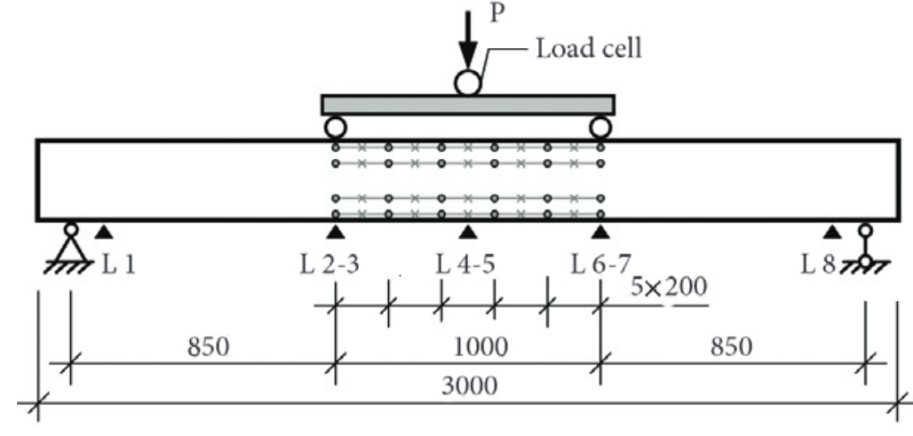
Fig. 1 - Testing scheme and layout of strain gauges on beams of the first series for bending tests

Table 1. Physical and mechanical properties of supports
Equations are inserted into the text in the form of tables with two columns and one row. All equations are numbered, including those that are not referenced in the text:
(1)

Conclusions

Acknowledgements

Fundings

References
References must meet the requirements https://alfabuild.spbstu.ru/en/references/

